**Displaying Data with Pipes:**

Displaying Dates in a particular format in Angular

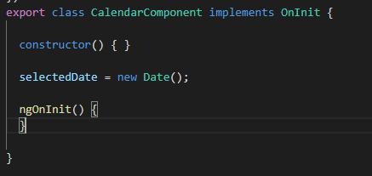

Now, show the date

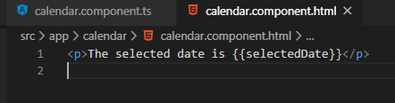

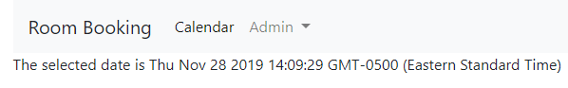

Now use Pipes:



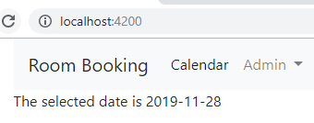

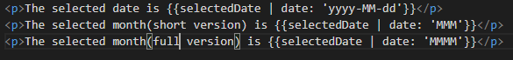

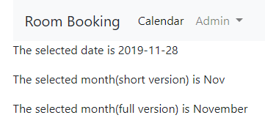

<http://angular.io/guide/pipes>

Programmatic Date

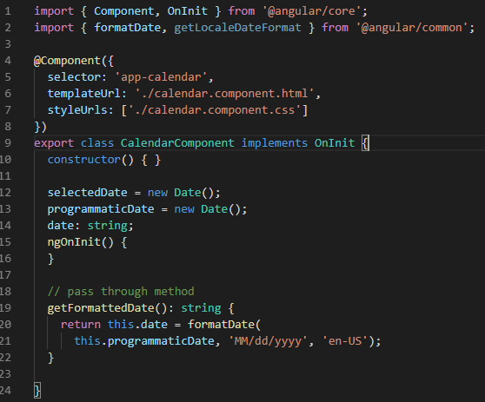



Displaying the Calendar Screens:

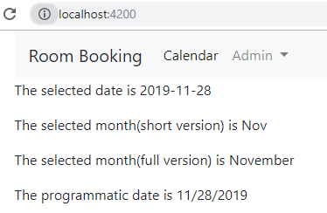

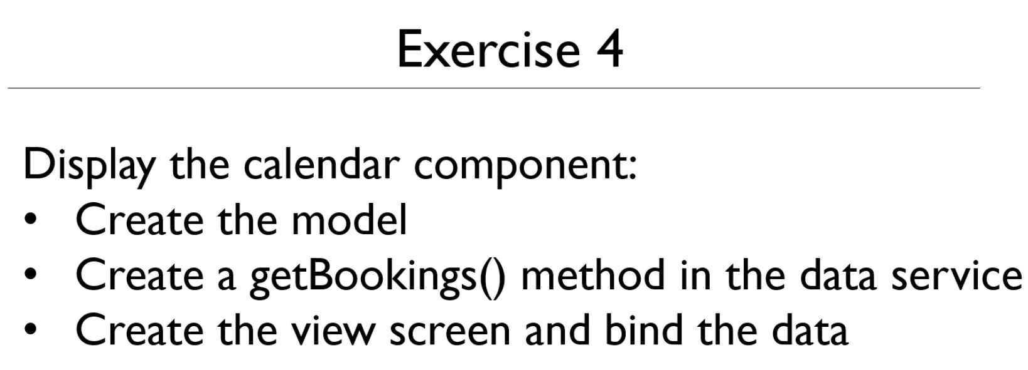

Create the model Booking.ts

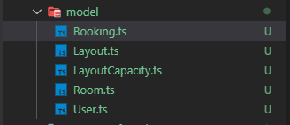

Copy the starting workspace model and edit for typescript

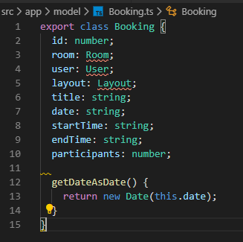

Need to fix imports

To import first highlight, Ctrl + . then Enter

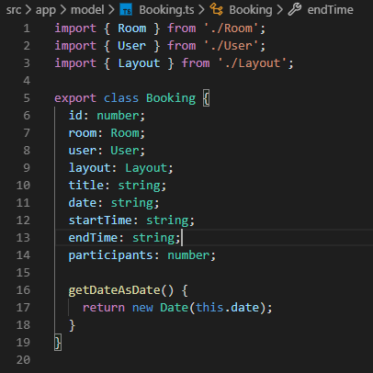

Create Dummy Array of Data in the DataService

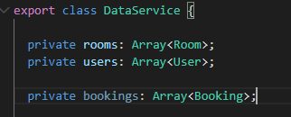

Data:

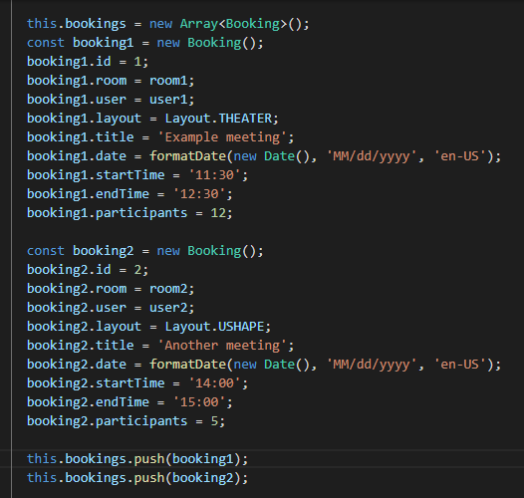

Method for obtaining the booking

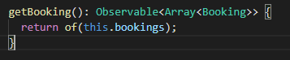

That completes the data service

Let us now create the view

So, in the Calendar component paste the following

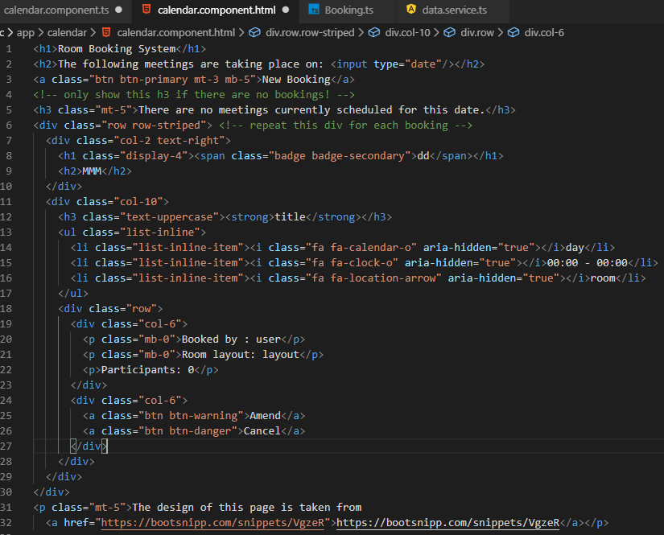

Let us create a reference to the bookings data in the calendar.component.ts file

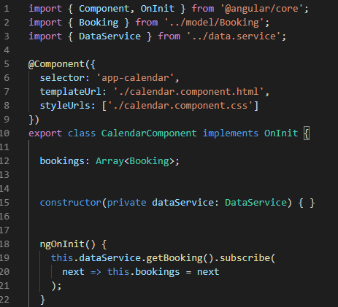

Now, bind the data to the html

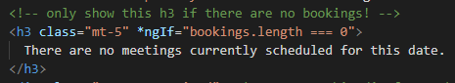

We need to loop of bookings

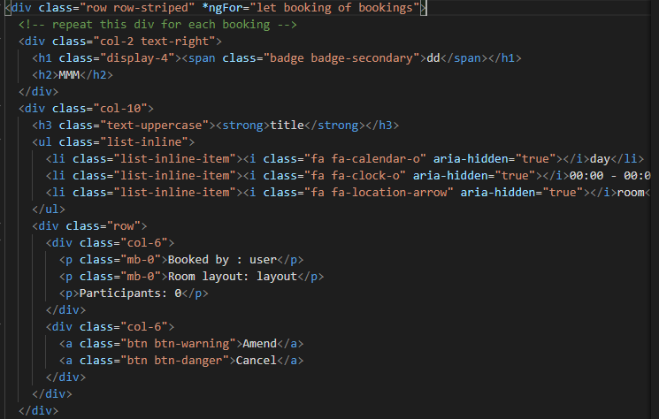

Add the date

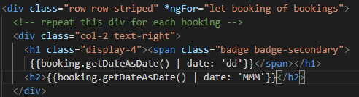

Test this

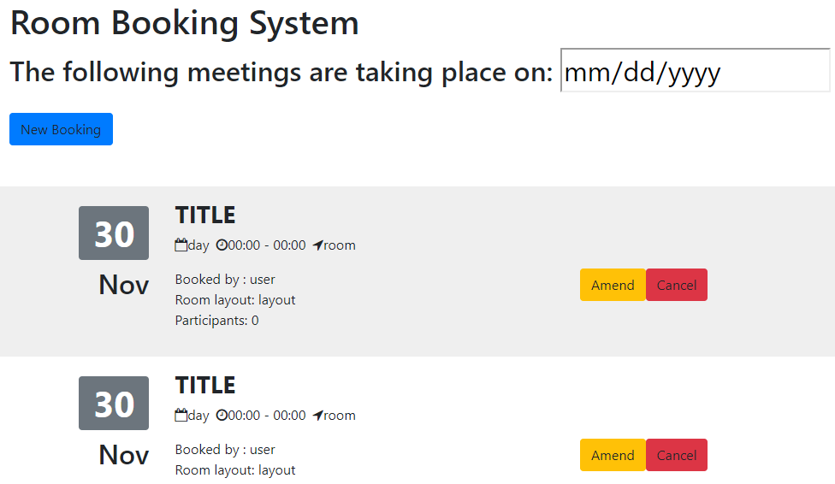

Add the Booking Title



Add the day, times and room

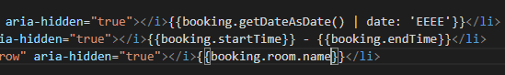

Test it

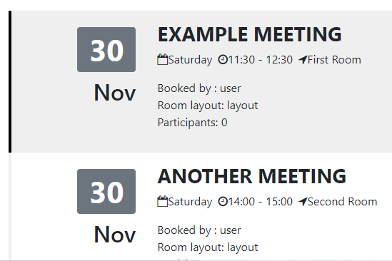

Add user, layout and participants

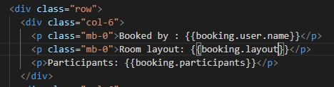

Test it

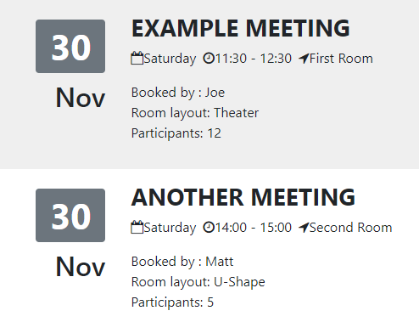

Next the Edit Screen: Exercise 5

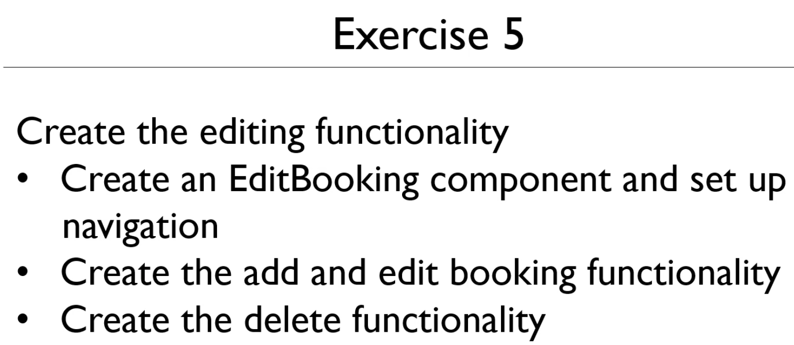

Create a EditBooking Component:

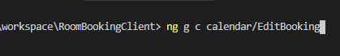

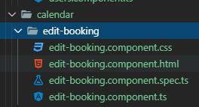

Add a booking element to the class

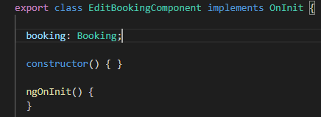

Add the html

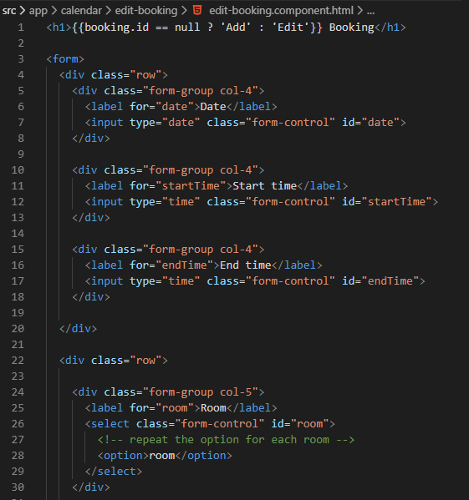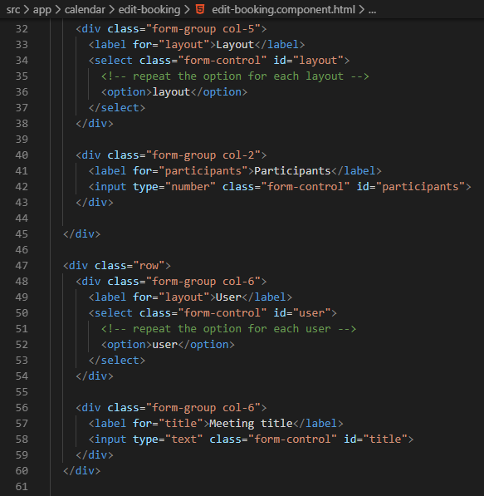

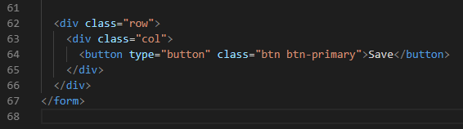

Start binding elements

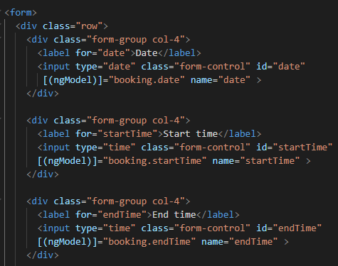

Create a backing object rooms

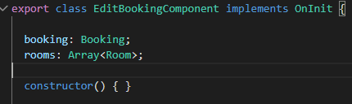

Source of the data is the dataService

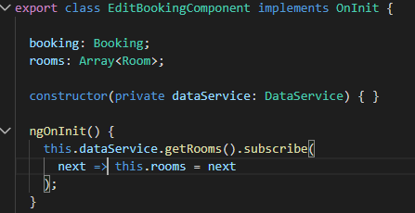

Now, loop through the rooms

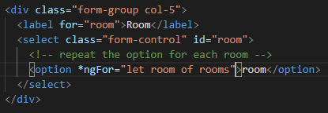

Binding room and outputting the room name

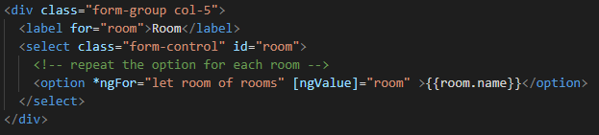

Bind the select to actual booking room

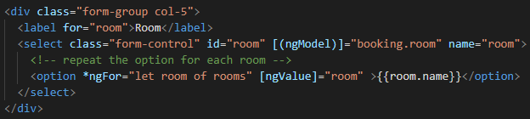

Do the same for the Layout

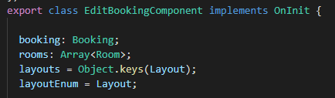

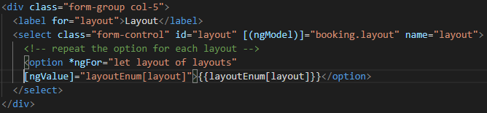

Let us do the participants

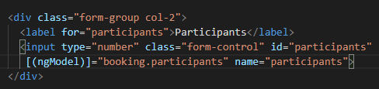

Now the loop for the users

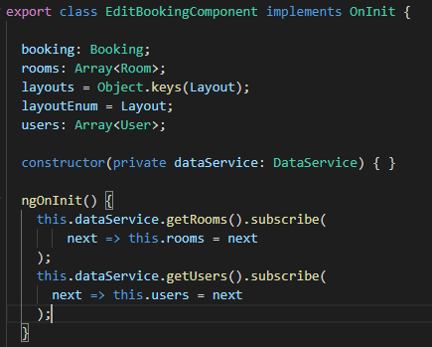

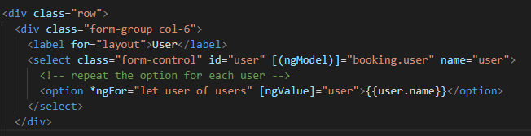

Now, meeting title

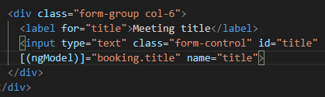

Now, set up the navigation

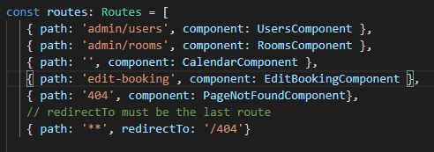

Test it

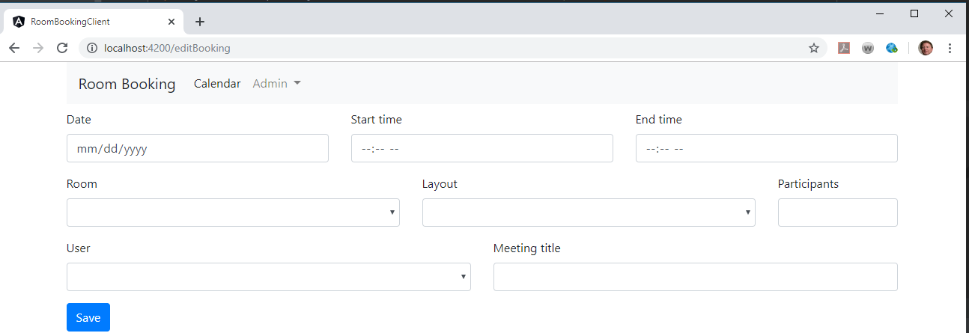

Still more work to clean up console errors

Complete the routing off the button click

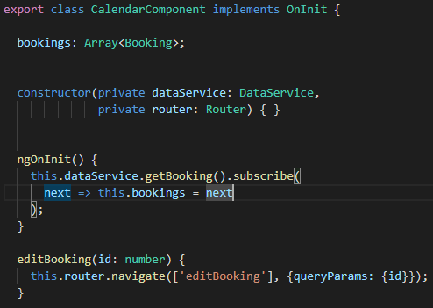

Bind the click event to the Amend button

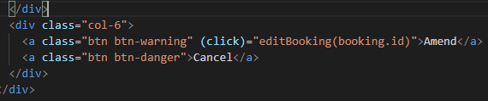

Test this by clicking amend

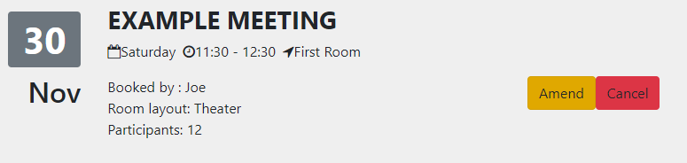

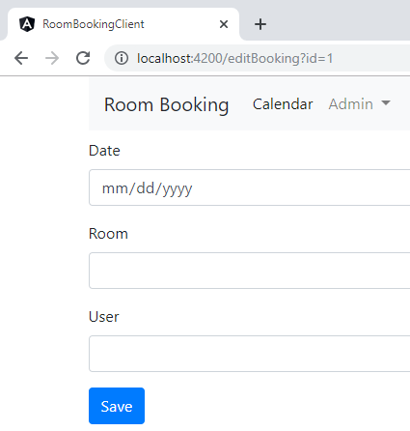

Let us grab the id by getting a reference to the activated route

The getBooking() that was already present had to be refactored to getBookings();

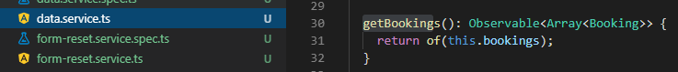

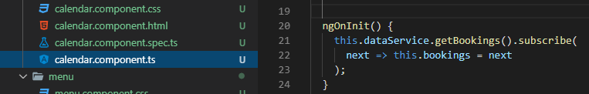

Now use getBooking() for the new method



Back to the editBooking class

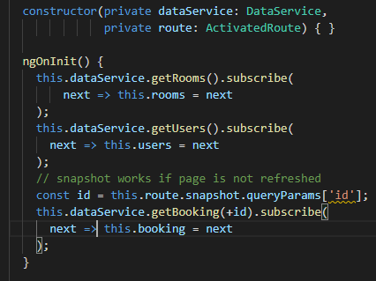

Test it

On clicking the Amend on the first Booking - data is populated correctly

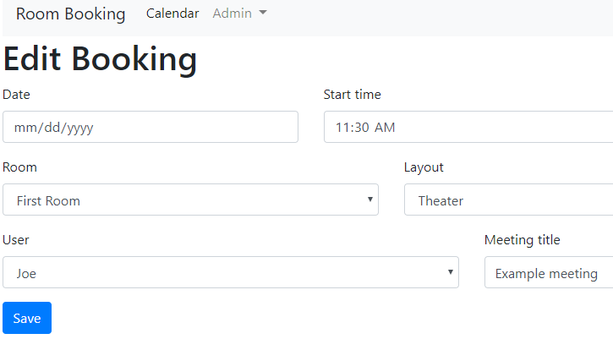

Implement the Save button

In the dataService

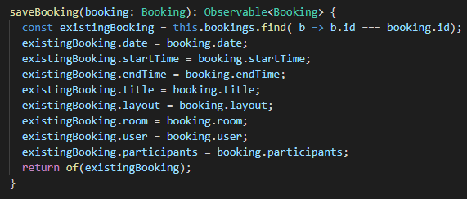

Create the pass through method in the EditBooking class

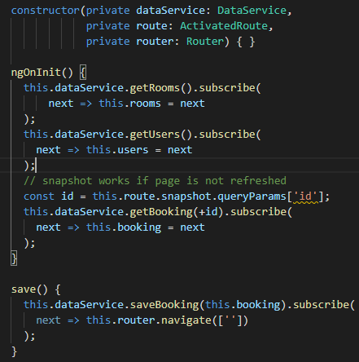

Bind the save() to the button Save In the editBooking html file

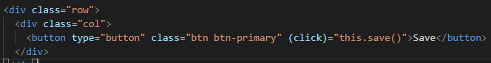

Test this by editing a booking

Changed startTime from 11:30, Layout from Theatre, and participants from 12.

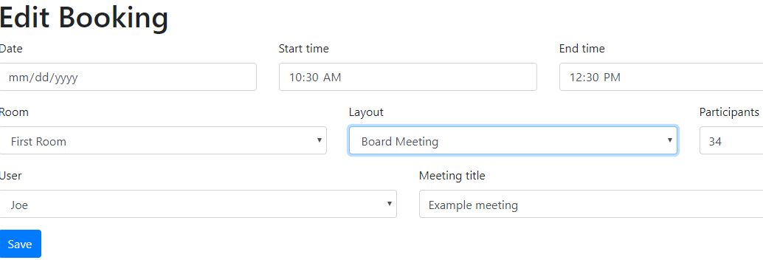

Changes were saved

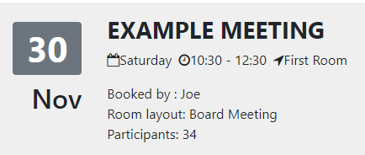

Now create a new URL for our New Booking button That is addBooking

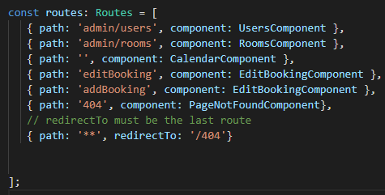

Now the click method in the calendar class

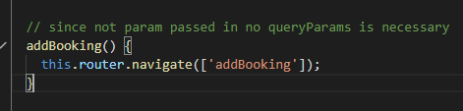

Need a null check on id

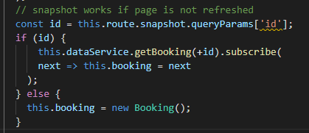

Create addBooking in the dataService

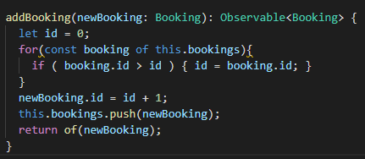

Fix the save() for id check

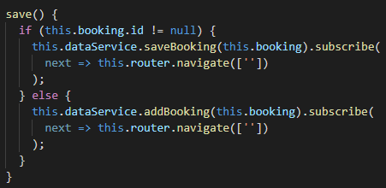

Bind the addBooking for the Click event

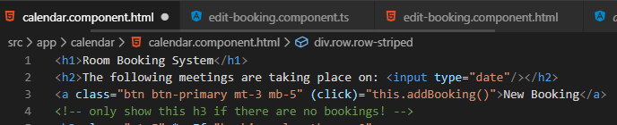

Test it Click new booking button

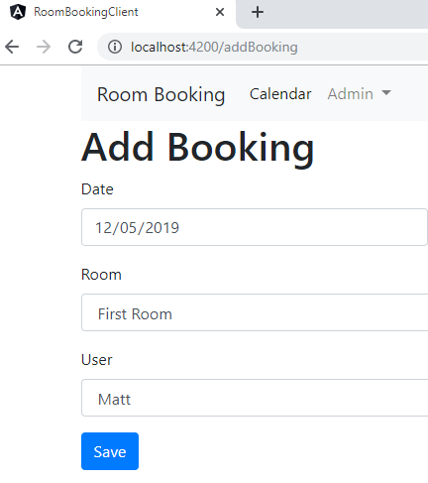

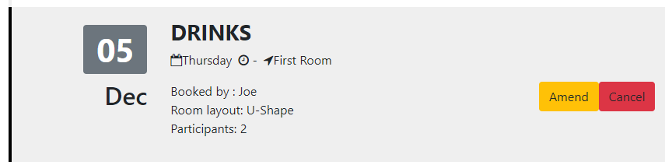

It worked!!

Implement the Cancel button

In the dataservice

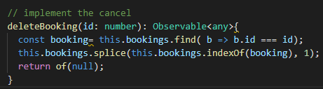

Pass through method is in the calendar class

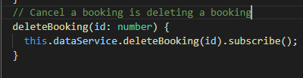

Databind in the html page

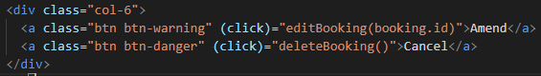

Test it

Default is 2 bookings successfully removed one

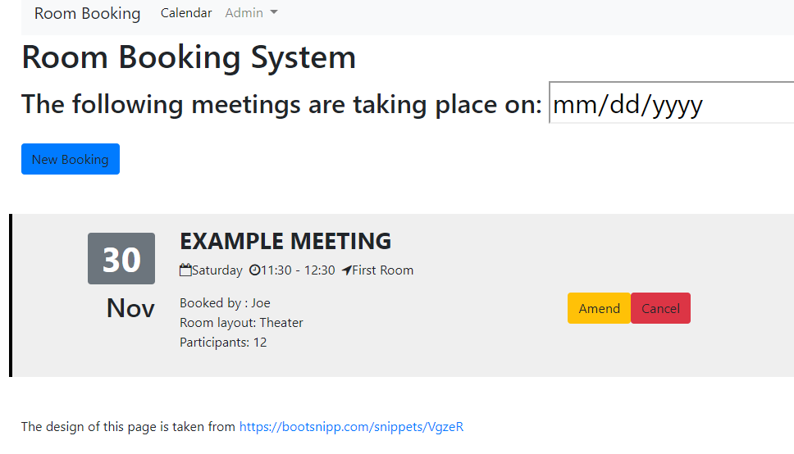

Now let us get the Calendar component to work

Let us create a selectedDate of type string

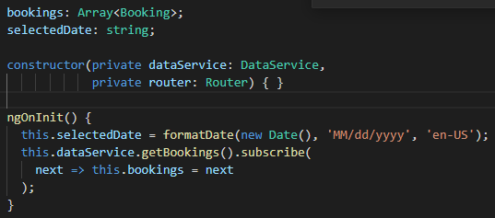

Bind the selectDate

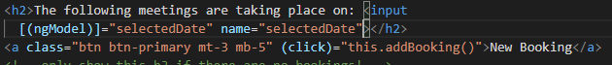

Test it

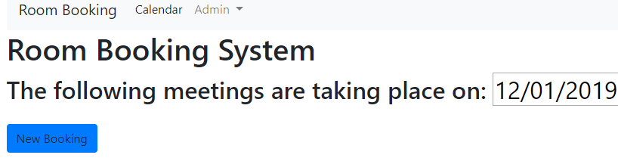

Update the date in the bookings if changed in the calendar

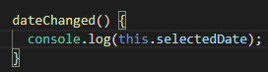

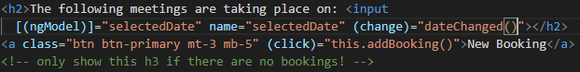

Test that date shows up in the console

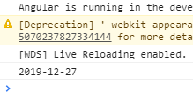

Redo dataservice getBookings() to handle dates



Now add navigation

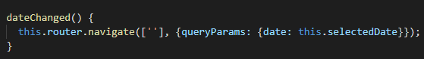

Need the ActivatedRoute and refactor the methods

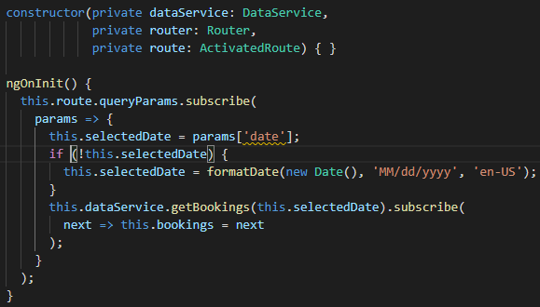

Test it

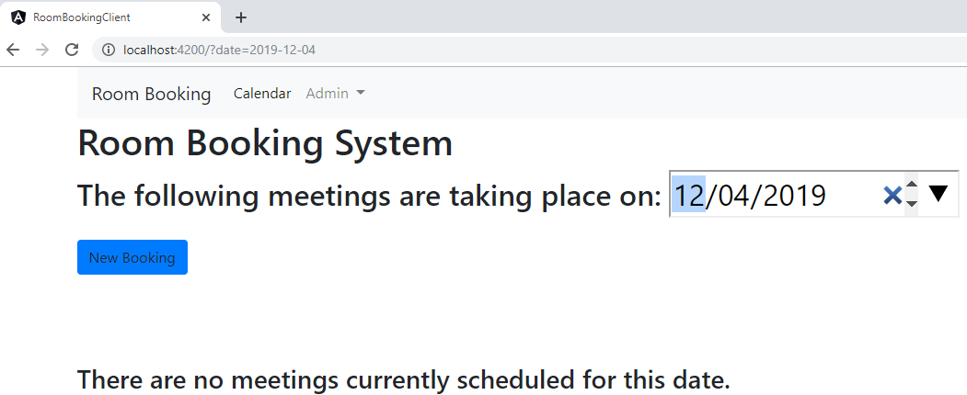

<h1>{{booking.id == null ? 'Add' : 'Edit'}} Booking</h1>

<form>

<div class="row">

<div class="form-group col-4">

<label for="date">Date</label>

<input type="date" class="form-control" id="date">

</div>

<div class="form-group col-4">

<label for="startTime">Start time</label>

<input type="time" class="form-control" id="startTime">

</div>

<div class="form-group col-4">

<label for="endTime">End time</label>

<input type="time" class="form-control" id="endTime">

</div>

</div>

<div class="row">

<div class="form-group col-5">

<label for="room">Room</label>

<select class="form-control" id="room">

<!-- repeat the option for each room -->

<option>room</option>

</select>

</div>

<div class="form-group col-5">

<label for="layout">Layout</label>

<select class="form-control" id="layout">

<!-- repeat the option for each layout -->

<option>layout</option>

</select>

</div>

<div class="form-group col-2">

<label for="participants">Participants</label>

<input type="number" class="form-control" id="participants">

</div>

</div>

<div class="row">

<div class="form-group col-6">

<label for="layout">User</label>

<select class="form-control" id="user">

<!-- repeat the option for each user -->

<option>user</option>

</select>

</div>

<div class="form-group col-6">

<label for="title">Meeting title</label>

<input type="text" class="form-control" id="title">

</div>

</div>

<div class="row">

<div class="col">

<button type="button" class="btn btn-primary">Save</button>

</div>

</div>

</form>